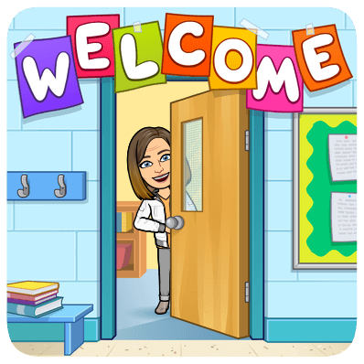
Family Wellness
Mrs. Amundson
Room 164
amundsonc@barron.k12.wi.us
715-537-5627 ext. 163
Google Classroom Code:nbcg3mb

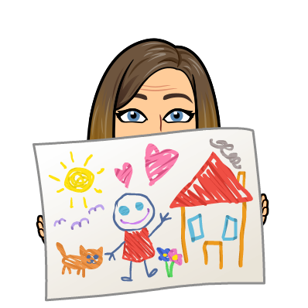
Course Description Family Wellness focuses on the role of the family in helping individuals reach the highest potential by addressing concerns of the community and global society. Emphasis is given to the dynamics of family life, developing and strengthening relationships, responsible parenting, communication within families, crisis management, civic responsibility, healthy living, housing decisions, career planning and trends affecting families. We will explore the foundation of the family and focus on skills that contribute to a successful family life.

Course Topics
- Strengthening Families
- Life Cycle, Family Roles
- Birth Order, Genetics
- Self Esteem, Self Concept, Self Care
- Communication/Conflict Resolution
- Aging/Geriatrics
- Family Stress & Coping
- Domestic Abuse, Relationships
- Careers

Items Needed for Class
- School issued laptop AND charger
- Writing tool - pen/pencil
- Folder to organize handouts/assignments

Grading Procedure -
- Please check IC often and let me know if you have any questions about a particular grade
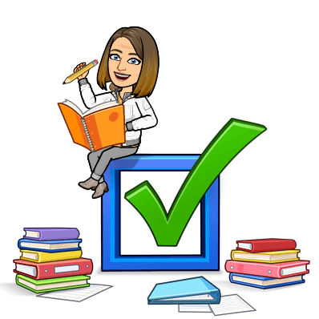
- Grades will be available in Infinite Campus and updated weekly.

District Grading Scale:
93-100%A 90-92% A-
88-89% B+ 83-87% B 80-82% B-
78-79% C+ 73-77% C 70-72% C-
68-69% D+ 63-67% D 60-62% D-

Assignments/Grades
- Assignments will be turned in through google classroom
- It is YOUR responsibility to check Google Classroom for assignments.

Classroom Expectations
- Be on time.
- Be respectful. This means of fellow students and their property, school property and me.
- Phones in classroom phone holder
- Always come prepared for class - computer, writing tool
- No outside food or drinks in the classroom.
- Be an active member of your group.
- Have fun!
